Installation Guide - HOUSEMAX

Prerequisites
Before you begin, ensure you have the following installed on your machine:
- Node.js: Version 18.0 or higher
- npm: Included with Node.js
- Git: For cloning the repository

Step-by-Step Installation

1. Clone the Repository
Open your terminal or command prompt and run the following command to download the project files:
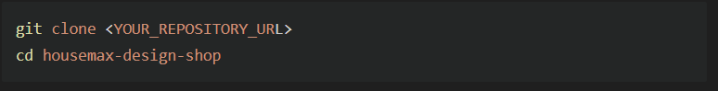
2. Install Dependencies
Install the required software packages (listed in `package.json`) by running:
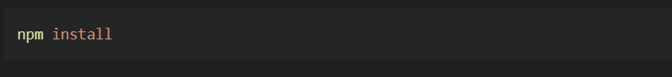
Tip: This may take a few minutes depending on your internet connection.

3. Environment Setup (Optional)
If you are connecting to a live Supabase instance or using Stripe, create a `.env` file in the root directory and add your keys:
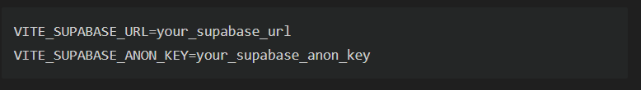
Note: The project comes with default demo configurations, so this step is optional for local testing.*

4. Run the Development Server
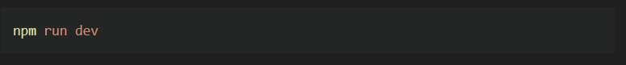
Start the local server to run the application:

5. Access the Application
Once the server starts, open your browser and navigate to:
http://localhost:5173

Troubleshooting
- "command not found: npm": Ensure Node.js is installed and added to your system PATH.
- Port 5173 already in use: The terminal will suggest another port (e.g., 5174). Use that link instead.
User Guide - HOUSEMAX

Welcome to HOUSEMAX, your all-in-one platform for interior design and furniture shopping. This guide will help you navigate the features and get the most out of your experience.

1. Getting Started

Sign Up / Login
1. Click the Profile icon in the top navigation bar.
2. Enter your Email and Password.
3. Click Sign Up to create a new account or Login if you already have one.
4. Once logged in, you can access your saved designs and order history.

2. Using the 3D Room Planner

The Planner allows you to visualize furniture in a virtual room before you buy.

Accessing the Planner
Click "Planner" in the main navigation menu.

Designing Your Room
- Draw Walls: Use the specialized tool to verify room dimensions (in meters).
- Add Furniture:
- Browse the Entity Library on the sidebar.
- Drag and Drop items like specific Chairs, Tables, or the new Bathtub and Shower models into the grid.
- Customize Items:
- Click on any item in the 3D view.
- Use the context menu to Resize (Width/Depth/Height) or Rotate the object.
- Apply Textures:
- Select a wall or floor.
- Choose from the Texture Panel (e.g., Marble Tiles, Hardwood, Geometric Patterns) to change the look.
- Save Project: Click the Save button to store your design (requires login).

Navigation Controls
- Left Click + Drag: Rotate the camera view.
- Right Click + Drag: Pan the camera (move side to side).
- Scroll Wheel: Zoom in and out.
- 2D/3D Toggle: Switch between floor plan view and 3D view using the toolbar button.

3. Shopping for Furniture

Browsing Products
- Navigate to the Shop page.
- Use the Filter Sidebar to sort by:
- Category (Living Room, Bedroom, etc.)
- Price Range
- Color
- Use the Search Bar to find specific items (e.g., "Blue Sofa").

Purchasing Items
1. Click "Add to Cart" on any product card.
2. Click the Cart Icon (top right) to review your items.
3. Proceed to Checkout.
4. Enter your Shipping Address and Payment Details.
5. Click Complete Payment. You will receive an order confirmation on screen.

4. AI Design Assistant
- Click the Chat Bubble icon (bottom right).
- Ask questions like "What color rug goes with a grey sofa?" to get personalized design advice.

